**VISVESVARAYA TECHNOLOGICAL UNIVERSITY**

**Jnana Sangama, Belagavi – 590 018**



A Project Report on

**“SMART HEALTH MONITORING SYSTEM FOR QUARANTINED COVID – 19 PATIENTS ”**

Project report submitted in partial fulfilment of the requirement for the award of the degree of

**BACHELOR OF ENGINEERING**

**IN**

**ELECTRONICS AND COMMUNICATIONS**

**Submitted by**

**B V THARANI 1GD18EC010**

**SHUSHMITHA PS** **1GD18EC039**

**VARALAKSHMI G 1GD18ECO43**

**Under the Guidance of**

**Mrs. N. Raja Thejaswini**

**Professor, Dept. of ECE**

**GCEM**

**Department of Electronics & Communication**

**GOPALAN COLLEGE OF ENGINEERING & MANAGEMENT**

**[Affiliated to VTU, Belagavi, Approved by AICTE, New Delhi]**

**181/1, 181/2 Hoodi Village, Sonenahalli, K.R. Puram, Bangalore - 560 048**

**GOPALAN COLLEGE OF ENGINEERING AND MANAGEMENT**

**[Affiliated to VTU, Belagavi, Approved by AICTE, New Delhi] 181/1,182/1, Hoodi village, sonnenahalli,K.R.Puram,Bangalore-560048**

**Department of Electronics and Communication Engineering**

**CERTIFICATE**

It is certified that the project work entitled **“ SMART HEALTH MONITORING SYSTEM FOR QUARANTINED COVID – 19 PATIENTS ”** is a bonafied work carried out by **B V THARANI, SHUSHMITHA PS, VARALAKSHMI G** in partial fulfilment for the award of the degree of **Bachelor of Engineering** in **Electronics and Communication** affiliated to Visvesvaraya Technological University, Belagavi during the year, 2021-2022.

**Signature of Guide Signature of HOD Signature of Principal**

Mrs. N. Raja Thejaswini Dr.S. Anantha Padmanabhan Dr.N. Sengottaiyan

Assistant Professor, HOD, Dept.of ECE, Principal,

Dept. of ECE,GCEM GCEM GCEM

**EXTERNAL VIVA**

**Name of the Examiner: Signature with Date:**

**1**

**2**

**DECLARATION**

We, the students of 7th semester, Electronics and Communication Engineering, Gopalan College of Engineering, GCEM Bangalore – 560048, declare that the project work entitled **“ SMART HEALTH MONITORING SYSTEM FOR QUARANTINED COVID – 19 PATIENTS “** has been successfully completed under the guidance of Mrs. N. Raja Thejaswini Professor, Department of Electronics and Communication Engineering, Gopalan College of Engineering and Management, Bangalore. This dissertation work is submitted to Visvesvaraya Technological University in partial fulfilment of the requirements for the award of Degree of Bachelor of Engineering in Electronics and Communication Engineering during the academic year 2021-2022. We assure that the above project was not conducted in any Engineering college as per our knowledge and corrections are done by the guide incorporated in the report.

**Date:**

**Place: Bangalore**

**Team member’s Signature**

**B V THARANI**

**SHUSHMITHA PS**

**VARALAKSHMI G**

he success and final outcome of this internship required a lot of guidance and assistance

from many people and I am extremely privileged to have got this all along the completion

of my internship. All that I have done is only due to such supervision and assistance and I

from many people and I am extremely privileged to have got this all along the completion

of my internship. All that I have done is only due to such supervision and assistance and I

The success and final outcome of this internship required a lot of guidance and assistance

from many people and I am extremely privileged to have got this all along the completion

The success and final outcome of this internship required a lot of guidance and assistance

from many people and I am extremely privileged to have got this all along the completion

**ABSTRACT**

In the current pandemic situation the Covid patients are increasing rapidly. To monitor all the Covid patients is very stressful for the doctors and needs a lot of patience. The main problem is fear of infection to doctors and their families. To overcome this, we are making Health Monitoring system. This device will monitor the patient health continuously. This device will monitor the patient temperature and heart-rate. As we know the coronavirus and other viruses are dangerous and harmful to society. With the help of this system we can keep a track of patients health conditions if they need any medical help they can alert the respective authorities at a press of a button.

**TABLE OF CONTENTS**

|  |  |  |
| --- | --- | --- |
| **Chapter No.** | **Chapter Title** | **Page No.** |
| **1.** | **Introduction**   * 1. General introduction about IoT   2. Introduction of the project   1.3 Objective of the project | 1  4  5 |
| **2.** | **Literature survey** | 6 |
| **3.** | **System Study and Analysis**  3.1 Existing Methodology  3.2 Proposed Methodology | 10  11 |
| **4.** | **System Requirements**  4.1 Hardware Requirements  4.1.1 Arduino UNO  4.1.2 GPS Module  4.1.3 GSM Module  4.1.4 MAX30100 Sensor Module  4.2 Software Requirements  4.2.1 Arduino IDE | 12  15  17  20  21 |
| **5.** | **Design Methodology**  5.1 Block Diagram | 24 |
| **6.** | **Result** | 26 |
| **7.** | **Advantages And Applications**  7.1 Advantages  7.2 Applications | 29  29 |
| **8.** | **Conclusion And Future Scope**  8.1 Conclusion  8.2 Future scope | 30  31 |
|  | **References** | 32 |

**LIST OF FIGURES**

|  |  |  |
| --- | --- | --- |
| **Figure No.** | **Figure Name** | **Page No.** |
| 1 | Arduino UNO board | 13 |
| 2 | GPS Module | 15 |
| 3 | GSM Module | 18 |
| 4 | MAX30100 Sensor Module | 20 |
| 5 | Arduino IDE | 21 |
| 6 | Block Diagram | 24 |
| 7 | Output of MAX30100 Sensor Module | 27 |
| 8 | Output of GPS Module | 27 |
| 9 | Output of GSM Module | 28 |

**CHAPTER 1:**

**INTRODUCTION**

# **1.1: GENERAL INTRODUCTION ABOUT IoT**

The Internet of things (IOT) describes the network of physical objects "things"— that are embedded with sensors, software, and other technologies for the purpose of connecting and exchanging data with other devices and systems over the Internet.

Things have evolved due to the convergence of multiple technologies, real-time analytics, machine learning, ubiquitous computing, commodity sensors, and embedded systems. Traditional fields of embedded systems, wireless sensor networks, control systems, automation (including home and building automation), and others all contribute to enabling the Internet of things. In the consumer market, IoT technology is most synonymous with products pertaining to the concept of the "smart-home", including devices and appliances (such as lighting fixtures, thermostats, home security systems and cameras, and other home appliances) that support one or more common ecosystems, and can be controlled via devices associated with that ecosystem, such as smartphones and smart speakers. The IoT can also be used in healthcare systems. There are a number of serious concerns about dangers in the growth of the IoT, especially in the areas of privacy and security, and consequently industry and governmental moves to address these concerns have begun including the development of international standards.

The concept of the "Internet of Things" and the term itself, first appeared in a speech by Peter T. Lewis, to the Congressional Black Caucus Foundation 15th Annual Legislative Weekend in Washington, D.C, published in September 1985.According to Lewis, "The Internet of Things, or IoT, is the integration of people, processes and technology with connectable devices and sensors to enable remote monitoring, status, manipulation and evaluation of trends of such devices.

" The term "Internet of things" was coined independently by Kevin Ashton of Procter & Gamble, later MIT's Auto-ID Centre, in 1999, though he prefers the phrase "Internet for things". At that point, he viewed radio-frequency identification (RFID) as essential to the

Internet of things, which would allow computers to manage all individual things. The main theme of the Internet of Things is to embed short-range mobile transceivers in various gadgets and daily necessities to enable new forms of communication between people and things, and between things themselves

**Applications:**

The extensive set of applications for IOT devices is often divided into consumer, commercial, industrial, and infrastructure spaces.

**Industrial applications:**

Also known as IIOT, industrial IOT devices acquire and analyse data from connected equipment, operational technology (OT), locations, and people. Combined with operational technology (OT) monitoring devices, IIOT helps regulate and monitor industrial systems. Also, the same implementation can be carried out for automated record updates of asset placement in industrial storage units as the size of the assets can vary from a small screw to the whole motor spare part, and misplacement of such assets can cause a percentile loss of manpower time and money.

**Trends and Characteristics:**

The IoT's major significant trend in recent years is the explosive growth of devices connected and controlled by the Internet. The wide range of applications for IoT technology mean that the specifics can be very different from one device to the next but there are basic characteristics shared by most. The IoT creates opportunities for more direct integration of the physical world into computer-based systems, resulting in efficiency improvements, economic benefits, and reduced human exertions. The number of IoT devices increased 31% year-over-year to 8.4 billion in the year 2017 and it is estimated that there will be 30 billion devices by 2020.The global market value of the IoT is projected to reach $7.1 trillion by 2020.

**1.2: INTRODUCTION OF THE PROJECT**

In the current COVID situation we have special Covid – 19 Quarantine centres set up to treat covid patients. Since covid is highly infectious it is very important to quarantine covid patients continuously but at the same time, doctors need to monitor the health of covid patients too. With the increasing number of cases, it is becoming difficult to keep track of the health conditions of many quarantined patients.

The main problems are list out here:

1. Doctors need to regularly monitor the patient health.
2. The Doctors are at risk of infection just for monitoring purposes.
3. There are increasing numbers of patients for the doctors to monitor.

To solve these issues we are here to design a remote health monitor system that allows for remotely monitoring of multiple covid patients over the internet. The system monitors the patient Heart-beat, Temperature using a Sensor Module (MAX 30100).

The system then transmits this data over the internet using Wi-Fi which is integrated with the GSM Module. The entire system is run by microcontroller based circuitry. The data of the covid patient is transmitted and received and remotely. If any abnormal condition is detected in patient health, an alert is sent in the form of SMS to the medical authorities and Ambulance driver.

**1.3: OBJECTIVE OF THE PROJECT**

1. To find out the Covid affected patient as soon as possible so that person’s life can be at a low risk.
2. To design and implement Smart health monitoring system.
3. The main purpose is to detect SpO2, Heart-Rate and Temperature using MAX30100 Sensor Module.
4. To send the patient’s location to Ambulance Driver using GPS Module.
5. Using GSM Module we can send an alert to the Doctor as well as Ambulance Driver.
6. To learn new concepts and work as a team.

**CHAPTER 2:**

**LITERATURE SURVEY**

* From a view of R. P. Singh et. al., the emergence of the Internet of Things has an impact on reducing healthcare costs and improving the treatment of Covid – 19 infected patients. Twelve important IoT applications were identified and discussed for Covid – 19 disease. Ultimately, this forces researchers, scholars and scientists to find effective solutions to help overcome this pandemic. With the help of technology, researchers, doctors, governments and scientists can create a better environment for fighting this disease.[1]
* O. Taiwo et. al. addressed, use off technology can help in reducing workload on doctors and medical staff in pandemic. They developed application of IoT in smart home automation which consists of various sensors and Wi-Fi Module that provides real time health related updates of patients to the healthcare workers and doctors. Significances of their study is that, self – isolated or self- quarantined patients can send daily updates of their symptoms them.[2]
* From the perspective of Rin to Priambodo et. al., self – isolated COVID – 19 patient monitoring system for monitoring physiological data and heart rate and patient location information. Develop a healthcare monitoring system depends on the IoT, which has a network of human sensors and a gateway through which data can be collected and transmitted. The system also uses an application server on which data can be stored, analysed, and visualized. They can monitor the condition of patients who are trying to recover self – isolation at any time and take necessary preventive measures.[3]
* College of Computer Science and Information Technology, King Faisal University, Al Ahsa, Saudi Arabia – Novel Corona Virus is the most recent pandemic, which has struck more than 210 Countries and territories all over the world placing states in a perilous position. WHO has laid stress upon the governments worldwide to guarantee competent surveillance and identification of infected individuals to control severity of COVID – 19 pandemic effects. Therefore, our study highlights numerous technological solutions, which are of great help in controlling disease spread and facing challenges caused by it.
* The author has presented “An IOT Based Health care monitoring system”. Constant observation is required in hospitals where the patients are under medical care for a longer period of time. Although the patient is not in a critical situation, the doctors still need confirmation on their health parameters. Now a day, the expenses for hospitalization are high and expensive. So the health policies in various countries have shifted its focus from providing reactive, acute care to provide care outside the hospital. Hence author designs and build the sensing data that conditions the system to display accurate body parameters of the patients. The aim of this paper is to supervise the heart rate, blood pressure, temperature and ECG continuously through respective sensors. The recorded data is sent to the device and if the value exceeds, the alert message will be sent to the doctor.
* The author has presented “SInternet of Things as Key Enabler for Sustainable Healthcare Delivery”. Here the author considers IOT as a global network infrastructure, linking physical and virtual objects. This architecture consists of existing and evolving internet and network developments. Exclusive objectidentification, sensor and connection capability are offered. Hence sensors will be characterized by a high degree of data capture. This paper aims to show how radio frequencies are identified and Internet of Things technologies allow patients to access healthcare services.
* The author has presented “A Literature Survey in ECG Feature Extraction”. Patient’s health has been observed in this paper. There is a well organized health monitoring system developed and designed by author. The system enables the doctors to monitor patient’s health parameters (temp, heartbeat, ECG, position). The parameters of the patient are measured continuously (temp, heartbeat, ECG) and wirelessly transmitted using zigbee. It provides a solution for improving the performance and power management of the patient health monitoring system. The presented system is used to continuously observe and analyze the data in microcontroller. If a particular patient’s health parameter falls below the particular range, SMS is sent to the doctor’s mobile number using a standard GSM module. They have used Zigbee for wireless networking. The doctor can collect a record of a particular patient’s data by accessing the database of the patient on their respective PC which is persistently updated through Zigbee.
* The author presented “IOT Based Patient Monitoring System”. It is a mobile physiological monitoring system that is capable of continuously monitoring the patient’s heart rate using ECG. Using replaceable electrodes ECG sensor can be attached to the patient’s chest. Signals produced during muscle contraction is sensed by the system and recorded. The signals collected from the body are converted to an electrical signal. This paper shows the use of smart healthcare system. This new technology is capable of offering a large range of benefits to patients through early detection of abnormal conditions.
* The author presented “Health Monitoring Systems using IoT and Raspberry Pi”. IOT Raspberry Pi based health care monitoring system has been analyzed by author in this paper. Any unusualitiy in condition of patient health can be detected and informed to the related person of patient. The elemental component of ECG is Instrumentation Amplifier, which is responsible for taking the differences in the voltage. The exhibited system is efficient and easy to understand. It is a connection between patient and doctor.
* The author presented a “Review on-IOT Based smart healthcare system”. Here architecture of Smart Health Care Monitoring and IOT is demonstrated by author. New technologies help in minimizing the better quality as well security concept. ECG signals are obtained by electrodes that are placed on the chest. Later wires are connected to ECG sensor (AD8232).The sensor is used in measuring the electrical activity of the heart. Problems and challenges that could be faced in future are presented by this system. Applications of IOT can be improved using new methodologies and technologies. Sensors like Blood pressure, Temperature, Heart rate, ECG are used in IOT along with Raspberry Pi kit and Wi-Fi module.

**CHAPTER 3:**

**SYSTEM STUDY AND ANALYSIS**

* 1. **EXISTING METHODOLOGY**

IoT-based health monitoring system differs from the normal healthcare system in a very efficient way. Therefore, it becomes a bit challenging to achieve the required results and performances through IoT.

Working with IoT is related to the embedded world as the sensors use electronic data signals. Initially, devices such as sensors, detectors, monitors and microcontroller are connected altogether for synchronization. The sensors and detectors detect the signals in analog form, which needs to be further converted into digital form. The inbuilt analog to digital conversion is performed through the microcontroller to get data in proper digital format. The data are sent to Raspberry Pi that is being used as a microcontroller. Nowadays, the Raspberry Pi is most commonly and widely used in Internet of Things. After the conversion of data, storage of data is performed. The data are being sent to the cloud or server. In this research, a local server is used, which shows the variations of the values or the readings measured simultaneously.

* 1. **PROPOSED METHODOLOGY**

This device uses Sensor module which gives the proper values to the controller. Generally, in normal condition SpO2 ranges from 95-97 and temperature from 36-37. The values are recorded to identify the health condition of the patients during quarantine. So, they can be viewed from anywhere using Internet. The person must practice hand hygiene – wash hands for at least 20seconds. Place a fingertip on MAX30100 Oximeter Sensor. The sensor starts recording the data and send it to Arduino UNO. The Arduino UNO transmits the data to the mobile phone using GSM Module. The normal oxygen level (SpO2) level ranges from 95-98%. If the readings are above or below this range for a long time then the patient requires medical attention. Accordingly, the medical staff will take further actions. If the value reaches the threshold value, then the ambulance driver will get an alert through an SMS.

**CHAPTER 4:**

**SYSTEM REQUIREMENTS**

**4.1: HARDWARE REQUIREMENTS**

**4.1.1. ARDUINO UNO:**

The Arduino Uno is an [open-source](https://en.m.wikipedia.org/wiki/Open-source) [microcontroller board](https://en.m.wikipedia.org/wiki/Microcontroller_board) based on the [Microchip](https://en.m.wikipedia.org/wiki/Microchip_Technology) [ATmega328P](https://en.m.wikipedia.org/wiki/ATmega328P) microcontroller and developed by Arduino .cc . The board is equipped with sets of digital and analog [input/output](https://en.m.wikipedia.org/wiki/Input/output) (I/O) pins that may be interfaced to various [expansion boards](https://en.m.wikipedia.org/wiki/Expansion_board) (shields) and other circuits. The board has 14 digital I/O pins (six capable of [PWM](https://en.m.wikipedia.org/wiki/Pulse-width_modulation) output), 6 analog I/O pins, and is programmable with the [Arduino IDE](https://en.m.wikipedia.org/wiki/Arduino#Software) (Integrated Development Environment), via a type B [USB cable.](https://en.m.wikipedia.org/wiki/USB_cable) It can be powered by the USB cable or by an external [9-volt battery,](https://en.m.wikipedia.org/wiki/9-volt_battery) though it accepts voltages between 7 and 20 volts. It is similar to the [Arduino Nano](https://en.m.wikipedia.org/wiki/Arduino_Nano) and Leonardo. The hardware reference design is distributed under a [Creative Commons](https://en.m.wikipedia.org/wiki/Creative_Commons) Attribution Share-Alike 2.5 license and is available on the Arduino website. Layout and production files for some versions of the hardware are also available.

The word “Uno” means “one” in Italian and was chosen to mark the initial release of Arduino Software. The Uno board is the first in a series of USB-based Arduino boards and version 1.0 of the Arduino IDE were the reference versions of Arduino, which have now evolved to newer releases. The ATmega328 on the board comes preprogramed with a bootloader that allows uploading new code to it without the use of an external hardware programmer.

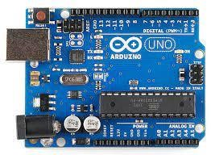While the Uno communicates using the original STK500 protocol, it differs from all preceding boards in that it does not use the FTDI USB-to-serial driver chip. Instead, it uses the Atmega16U2 (Atmega8U2 up to version R2) programmed as a [USB-to-serial converter.](https://en.m.wikipedia.org/wiki/USB-to-serial_converter)

## *Figure1: Arduino UNO board*

The Arduino Uno has a number of facilities for communicating with a computer, another Arduino board, or other microcontrollers. The ATmega328 provides UART TTL (5V) serial communication, which is available on digital pins 0 (RX) and 1 (TX). An ATmega16U2 on the board channels this serial communication over USB and appears as a virtual com port to software on the computer.

**Automatic (software) reset:**

Rather than requiring a physical press of the reset button before an upload, the Arduino Uno board is designed in a way that allows it to be reset by software running on a connected computer. One of the hardware flow control lines (DTR) of the ATmega8U2/16U2 is connected to the reset line of the ATmega328 via a 100 Nano farad capacitor. When this line is asserted (taken low), the reset line drops long enough to reset the chip.

This setup has other implications. When the Uno is connected to a computer running Mac OS X or Linux, it resets each time a connection is made to it from software (via USB). For the following half-second or so, the bootloader is running on the Uno. While it is programmed to ignore malformed data (i.e., anything besides an upload of new code), it will intercept the first few bytes of data sent to the board after a connection is opened.

**Features of the Arduino UNO:**

* Microcontroller: ATmega328
* Operating Voltage: 5V
* Input Voltage (recommended): 7-12V
* Input Voltage (limits): 6-20V
* Digital I/O Pins: 14 (of which 6 provide PWM output)
* Analog Input Pins: 6
* DC Current per I/O Pin: 40 mA
* DC Current for 3.3V Pin: 50 mA
* Flash Memory: 32 KB of which 0.5 KB used by bootloader
* SRAM: 2 KB (ATmega328)
* EEPROM: 1 KB (ATmega328)
* Clock Speed: 16 MHz

**4.1.2. GPS MODULE:**

The Global Positioning System (GPS), originally Navstar GPS, is a satellite-based radio navigation system owned by the United States government and operated by the United States Space Force. It is one of the global navigation satellite systems (GNSS) that provides geolocation and time information to a GPS receiver anywhere on or near the Earth where there is an unobstructed line of sight to four or more GPS satellites. Obstacles such as mountains and buildings can block the relatively weak GPS signals.

The GPS does not require the user to transmit any data, and it operates independently of any telephonic or Internet reception, though these technologies can enhance the usefulness of the GPS positioning information. The GPS provides critical positioning capabilities to military, civil, and commercial users around the world. The United States government created the system, maintains and controls it, and makes it freely accessible to anyone with a GPS receiver.

## NEO-6M GPS Module,U-blox NEO-6M GPS Module with EPROM*Figure 2: GPS module*

The GPS receiver calculates its own four-dimensional position in space time based on data received from multiple GPS satellites. Each satellite carries an accurate record of its position and time, and transmits that data to the receiver.

The satellites carry very stable atomic clocks that are synchronized with one another and with ground clocks. Any drift from time maintained on the ground is corrected daily. In the same manner, the satellite locations are known with great precision. GPS receivers have clocks as well, but they are less stable and less precise.

Global Positioning System applications generally fall into 5 major categories:

1.Location – determining a position.

2.Navigation – getting from one location to another.

3.Tracking – monitoring object or personal movement.

4.Mapping – creating maps of the world.

5.Timing – bringing precise timing to the world.

**4.1.3. GSM Module:**

The **Global System for Mobile Communications** (**GSM**) is a standard developed by the [European Telecommunications Standards Institute](https://en.wikipedia.org/wiki/European_Telecommunications_Standards_Institute) (ETSI) to describe the protocols for second-generation ([2G](https://en.wikipedia.org/wiki/2G)) digital [cellular networks](https://en.wikipedia.org/wiki/Cellular_network) used by mobile devices such as mobile phones and tablets. It was first deployed in [Finland](https://en.wikipedia.org/wiki/Finland) in December 1991. By the mid-2010s, it became a global standard for mobile communications achieving over 90% market share, and operating in over 193 countries and territories.

2G networks developed as a replacement for first generation ([1G](https://en.wikipedia.org/wiki/1G)) analog cellular networks. The GSM standard originally described a digital, circuit-switched network optimized for [full duplex](https://en.wikipedia.org/wiki/Duplex_(telecommunications)#Full_duplex) voice [telephony](https://en.wikipedia.org/wiki/Telephony). This expanded over time to include data communications, first by [circuit-switched transport](https://en.wikipedia.org/wiki/Circuit_Switched_Data), then by [packet](https://en.wikipedia.org/wiki/Network_packet) data transport via [General Packet Radio Service](https://en.wikipedia.org/wiki/General_Packet_Radio_Service) (GPRS), and [Enhanced Data Rates for GSM Evolution](https://en.wikipedia.org/wiki/Enhanced_Data_Rates_for_GSM_Evolution) (EDGE).

Subsequently, the [3GPP](https://en.wikipedia.org/wiki/3GPP) developed third-generation ([3G](https://en.wikipedia.org/wiki/3G)) [UMTS](https://en.wikipedia.org/wiki/UMTS) standards, followed by the fourth-generation ([4G](https://en.wikipedia.org/wiki/4G)) LTE Advanced and the fifth-generation [5G](https://en.wikipedia.org/wiki/5G) standards, which do not form part of the ETSI GSM standard.

"GSM" is a [trade mark](https://en.wikipedia.org/wiki/Trade_mark) owned by the [GSM Association](https://en.wikipedia.org/wiki/GSM_Association). It may also refer to the (initially) most common voice codec used, [Full Rate](https://en.wikipedia.org/wiki/Full_Rate).

As a result of the network's widespread use across Europe, the acronym "GSM" was briefly used as a generic term for mobile phones in France, the Netherlands and in [Belgium](https://en.wikipedia.org/wiki/Belgium). A great number of people in Belgium still use it to date. Beginning in the late 2010s, various carriers worldwide [started to shut down their GSM networks](https://en.wikipedia.org/wiki/GSM#Discontinuation).

GSM utilizes a [cellular network](https://en.wikipedia.org/wiki/Cellular_network), meaning that [cell phones](https://en.wikipedia.org/wiki/Cell_phone) connect to it by searching for cells in the immediate vicinity. There are five different cell sizes in a GSM network:

* [macro](https://en.wikipedia.org/wiki/Macrocell)
* [micro](https://en.wikipedia.org/wiki/Microcell)
* [pico](https://en.wikipedia.org/wiki/Picocell)
* [femto](https://en.wikipedia.org/wiki/Femtocell), and
* 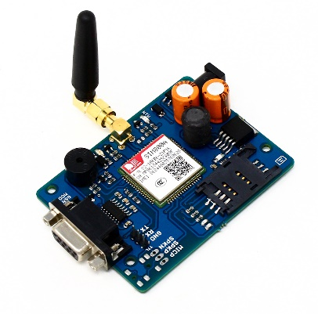umbrella cells

## *Figure 3: GSM Module*

The coverage area of each cell varies according to the implementation environment. Macro cells can be regarded as cells where the [base-station](https://en.wikipedia.org/wiki/Base_station) [antenna](https://en.wikipedia.org/wiki/Antenna_(electronics)) is installed on a mast or a building above average rooftop level. Micro cells are cells whose antenna height is under average rooftop level; they are typically deployed in urban areas. Picocells are small cells whose coverage diameter is a few dozen meters; they are mainly used indoors. Femtocells are cells designed for use in residential or [small-business](https://en.wikipedia.org/wiki/Small_business) environments and connect to a [telecommunications service provider](https://en.wikipedia.org/wiki/Telecommunications_service_provider)'s network via a [broadband-internet](https://en.wikipedia.org/wiki/Broadband_internet) connection. Umbrella cells are used to cover shadowed regions of smaller cells and to fill in gaps in coverage between those cells.

Cell horizontal radius varies – depending on antenna height, [antenna gain](https://en.wikipedia.org/wiki/Antenna_gain), and [propagation](https://en.wikipedia.org/wiki/Propagation_(disambiguation)) conditions – from a couple of hundred meters to several tens of kilometers. The longest distance the GSM specification supports in practical use is 35 kilometres (22 mi). There are also several implementations of the concept of an extended cell, where the cell radius could be double or even more, depending on the antenna system, the type of terrain, and the [timing advance](https://en.wikipedia.org/wiki/Timing_advance).

GSM supports indoor coverage – achievable by using an indoor picocell base station, or an [indoor repeater](https://en.wikipedia.org/wiki/Cellular_repeater) with distributed indoor antennas fed through power splitters – to deliver the radio signals from an antenna outdoors to the separate indoor distributed antenna system. Picocells are typically deployed when significant call capacity is needed indoors, as in shopping centers or airports. However, this is not a prerequisite, since indoor coverage is also provided by in-building penetration of radio signals from any nearby cell.

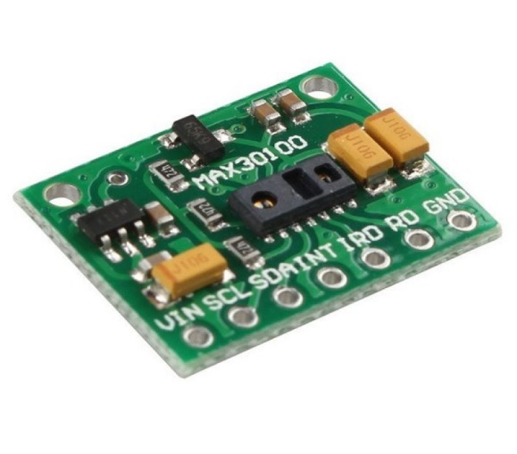**4.1.4. MAX30100 Sensor Module**

## *Figure 4: MAX30100 Sensor Module*

The MAX30100 is an integrated pulse oximetry and heart rate monitor sensor solution. It combines two LEDs, a photodetector, optimized optics, and low-noise analog signal processing to detect pulse oximetry and heart-rate signals.  
  
The MAX30100 breakout operates from 1.8V and 5.5V power supplies and can be powered down through software with negligible standby current, permitting the power supply to remain connected at all times.

**Features:**

* Working voltage: 1.8-5.5V
* Complete Pulse Oximeter and Heart-Rate Sensor Solution Simplifies Design
* Integrated LEDs, Photo Sensor, and High-Performance Analog Front -End
* Ultra-Low-Power Operation Increases Battery Life for Wearable Devices
* Programmable Sample Rate and LED Current for Power Savings
* Ultra-Low Shutdown Current (0.7µA, typ).

# **4.2: SOFTWARE REQUIREMENTS**

**4.2.1. ARDUINO IDE:**

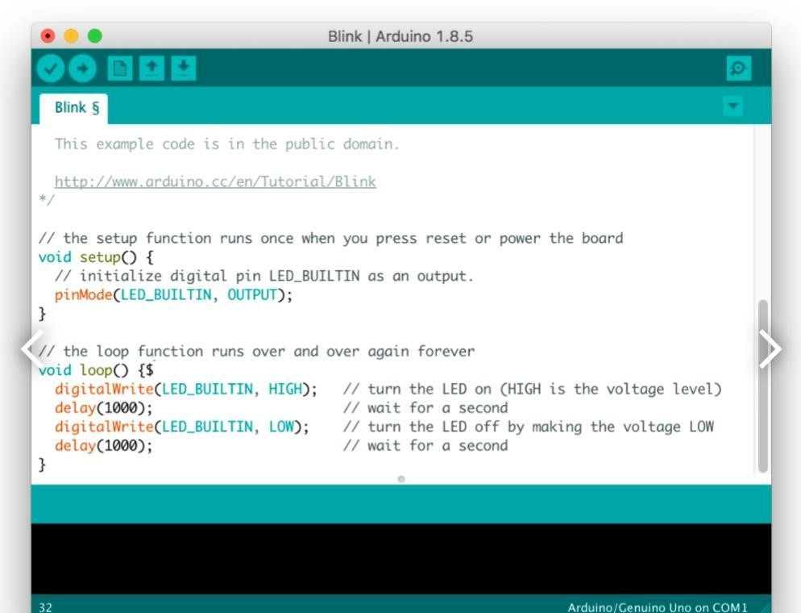Arduino is an open-source hardware and software company, project, and user community that designs and manufactures single-board microcontrollers and microcontroller kits for building digital devices. It’s hardware products are licensed under a CC BY-SA license, while software is licensed under the GNU Lesser General Public License (LGPL) or the GNU General Public License (GPL), permitting the manufacture of Arduino boards and software distribution by anyone. Arduino boards are available commercially from the *official website or through authorized distributors.*

## *Figure 5: Arduino IDE*

A program for Arduino hardware may be written in any programming language with compilers that produce binary machine code for the target processor. Atmel provides a development environment for their 8-bit AVR and 32-bit ARM Cortex-M based microcontrollers: AVR Studio (older) and Atmel Studio (newer)

The Arduino integrated development environment (IDE) is a cross-platform application (for Microsoft Windows, mac OS, and Linux) that is written in the Java programming language. It originated from the IDE for the languages Processing and Wiring. It includes a code editor with features such as text cutting and pasting, searching and replacing text, automatic indenting, brace matching, and syntax highlighting, and provides simple oneclick mechanisms to compile and upload programs to an Arduino board. It also contains a message area, a text console, a toolbar with buttons for common functions and a hierarchy of operation menus. The source code for the IDE is released under the GNU General Public License, version 2.

The Arduino IDE supports the languages C and C++ using special rules of code structuring. The Arduino IDE supplies a software library from the Wiring project, which provides many common input and output procedures. User-written code only requires two basic functions, for starting the sketch and the main program loop, that are compiled and linked with a program stub main() into an executable cyclic executive program with the GNU toolchain, also included with the IDE distribution. The Arduino IDE employs the program AVR dude to convert the executable code into a text file in hexadecimal encoding that is loaded into the Arduino board by a loader program in the board’s firmware.

From version 1.8.12, Arduino IDE windows compiler supports only Windows 7 or newer OS. On Windows Vista or older one gets“Unrecognized Win32 application” error when trying to verify/upload program. To run IDE on older machines, users can either use version 1.8.11, or copy “Arduino-builder” executable from version 11 to their current install folder as it’s independent from IDE.

IDE 2.0

On October 18, 2019, Arduino Pro IDE (alpha preview) was released. Later, on March 1, 2021, the beta preview was released, renamed IDE 2.0. The system still uses Arduino CLI (Command Line Interface), but improvements include a more professional development environment, auto completion support, and Git integration. The application frontend is based on the Eclipse Theia Open-Source IDE.

**CHAPTER 5**

**DESIGN METHODOLOGY**

**5.1 BLOCK DIAGRAM**

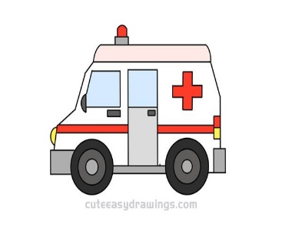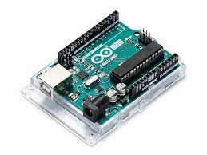****

ARDUINO UNO BOARD

AMBULANCE

MONITOR

GSM MODULE

Sensor Unit

GPS MODULE

COVID PATIENT

## *Figure 6: Block Diagram*

The figure shows the step-by-step process chart of the proposed model, it consists of Arduino UNO as the main microcontroller, sensor namely MAX30100 Sensor Module, a GPS module, GSM Module



SENSOR UNIT

GPS MODULE

**COVID 19 PATIENT**

**Design of System**

SENSOR UNIT

GPS MODULE

**COVID 19 PATIENT**

The whole workflow consists of the three main steps: data capturing, data processing followed by data storage, and displaying patients’ parameters on the monitor. Data capturing is the most important step as the precision and accuracy of measurements system depend solely on this step. In data capturing, the sensors to be used are connected with microcontroller. After making the hardware connections, the power supply of +5V is given to the microcontroller and to the sensors. The maximum power consumption of whole system is 7-8W. All the sensors used for measurement and data acquisition are IC based which takes small value of load current.

**Data Capturing**

Initially the sensors which are to be used are connected with microcontroller. After making accurate hardware connections, the power supply of + 5 V is given to the microcontroller and to the sensors. The MAX30100 non-contact temperature sensor is placed near the human body and it detects the temperature of patient.

**CHAPTER 6**

**RESULT**

The proposed project delivered desired results. All the hardware components like Arduino UNO, MAX30100 Sensor Module, GPS Module, GSM Module were implemented successfully with the help of Software-Arduino IDE for embedding the code.

Firstly, the MAX30100 Sensor Module detects the SpO2 and Heart-Rate of Covid patient.

Then using GPS Module we were able to track the patient’s live location along with the latitude and longitude.

When the detected value reaches the threshold value, an alert SMS is sent to the medical authorities, as well as the Ambulance Driver with the help of a GSM Module.

It can be inferred that all the codes embedded in Arduino UNO were precise, all the components worked in synchronisation and delivered the results.

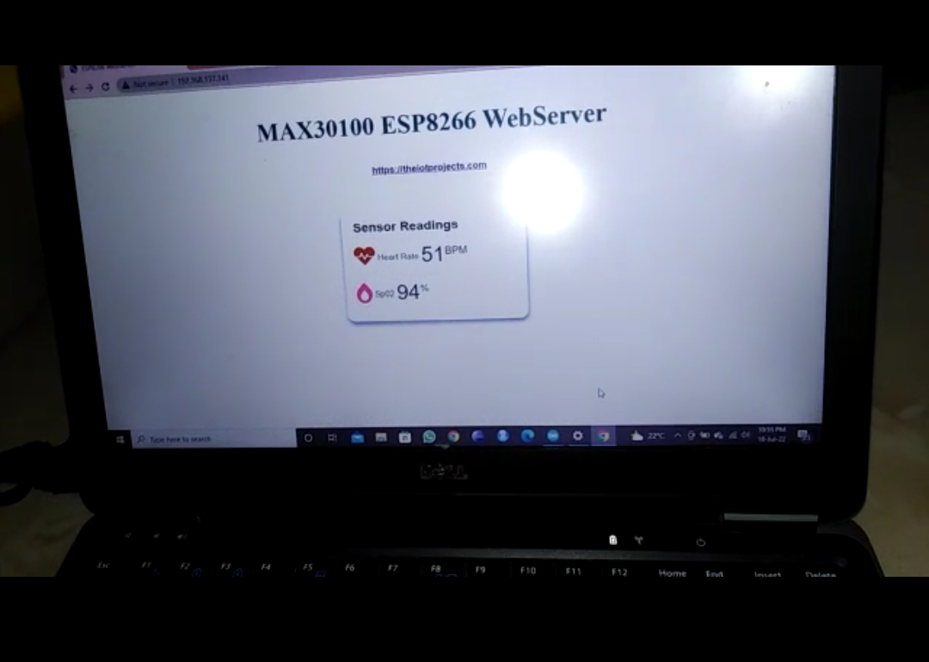The figures below shows the results obtained.

## *Figure 7: Output of MAX30100 Sensor Module*

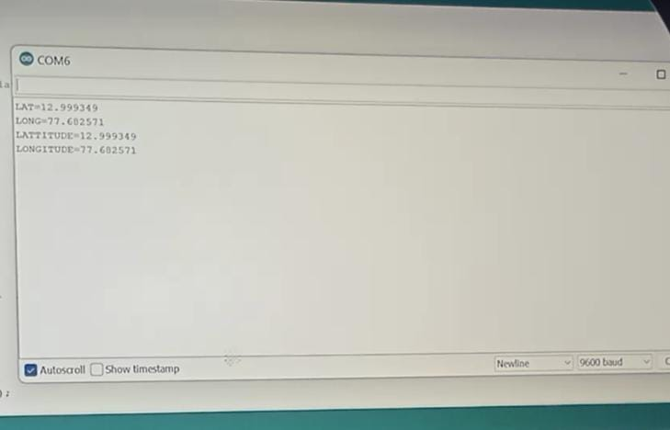

## *Figure 8: Output of GPS Module*

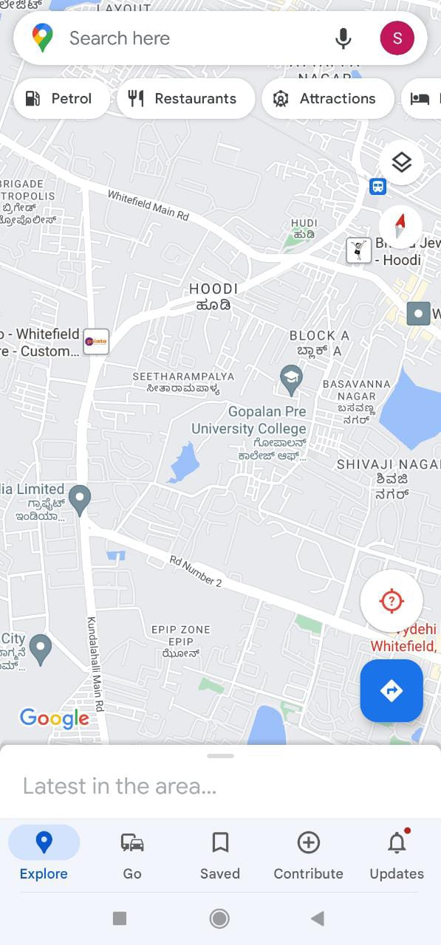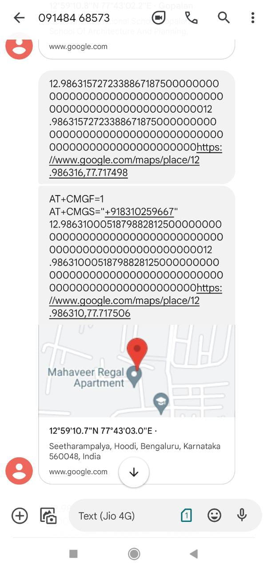

*Figure 9: Output of GSM Module*

## 

**CHAPTER 7**

**ADVANTAGES AND APPLICATIONS**

### **7.1 ADVANTAGES**

* Cost friendly.
* Easy to Operate.
* This Model is effective and is safe.
* The System is Safe even for users because no manual work required.
* By providing MAX30100 Sensors; it reduces the chances of losing of life .
* Since , this proposal is for medical cause; this reason also becomes a advantage.

**7.2 APPLICATIONS**

* This model is used in Hospitals.
* It can also be used in Old Age Homes as well as Orphanages.

**CHAPTER 8**

**CONCLUSION AND FUTURE SCOPE**

**8.1 CONCLUSION**

The proposed smart health monitoring system provides ease to the doctors to identify the patients’ information individually simply on the display monitor at their place. Doctors can distinguish the data of the particular patient regarding previous values with the present one. Along with data logging on the cloud, the Internet of Things also provides opportunities to add more advanced features or benefits and more biomedical sensors to this system. Therefore, the technology of IoT makes this monitoring system more flexible and more updatable in future. In this proposed work, we have taken advantage of technology to make patients’ lives easier for diagnosis and treatment by monitoring a person’s heart rate, oxygen level, and temperature. Thus contactless tracing and treatment of COVID-19 patient is quite with the usage of a developed IoT smart health monitoring system.

**8.2 FUTURE SCOPE**

* The developed system can be accommodated with more sensors and features for example shivering sensor, cough measuring unit, emergency button to make it more effective and useful for monitoring covid-19 patients. This system can be further used to monitor patients of asthma, tuberculosis and chest cold.
* This system can be further developed to find the nearest ambulance to the patient location. So that ambulance is alerted to pick the patient from his/her residence. Since the ambulances are now fitted with onboard GPS units for real time tracking. It provides an estimated time of arrival of the ambulance to the patient's residence just like we know the location of a taxi when we book through various apps on our mobile phones.

**REFERENCES**

1. Momtazmanesh S, et al. All together to fight COVID-19. Am J Trop Med Hyg. 2020;102(6):1181–3.
2. Iftekhar EN, et al. A look into the future of the COVID-19 pandemic in Europe: an expert consultation. Lancet Reg Health Eur. 2021;8:100185.
3. Thapliyal H, et al. Consumer Technology-based solutions for COVID-19. IEEE Consumer Electron Mag. 2021;10(2):64–5.
4. Priesemann V, et al. Towards a European strategy to address the COVID-19 pandemic. Lancet. 2021;398(10303):838–9.
5. Islam MM, Rahaman A, Islam MR. Development of smart healthcare monitoring system in IoT environment. SN Comput Sci. 2020;1(3):185.
6. Valsalan P, Baomar TAB, Baabood AHO. IOT based health monitoring system. J Crit Rev. 2020;7(4):739–43.
7. Senthamilarasi C, et al. A smart patient health monitoring system using IoT. Int J Pure Appl Math. 2018;119(16):59–70.
8. Islam SMR, et al. The Internet of things for health care: a comprehensive survey. IEEE Access. 2015;3:678–708.
9. Cirani S, Picone M. Wearable computing for the internet of things. IT Prof. 2015;17(5):35–41.
10. Guberović, E., T. Lipić, and I. Čavrak. Dew intelligence: federated learning perspective. in 2021 IEEE 45th Annual Computers, Software, and Applications Conference (COMPSAC). 2021.
11. do Nascimento LM, et al. Sensors and systems for physical rehabilitation and health monitoring—A review. Sensors. 2020;20(15):4063.
12. Li X, et al. Digital health: tracking physiomes and activity using wearable biosensors reveals useful health-related information. PLoS Biol. 2017;15(1):e2001402.
13. Bahmani A, et al. A scalable, secure, and interoperable platform for deep data-driven health management. Nat Commun. 2021;12(1):5757.
14. Anuar, H. and P.L. Leow. Non-invasive core body temperature sensor for continuous monitoring. in 2019 IEEE International Conference on Sensors and Nanotechnology. 2019.
15. Huang, P., et al. An embedded non-contact body temperature measurement system with automatic face tracking and neural network regression. in 2016 International Automatic Control Conference (CACS). 2016.
16. Rahaman A, et al. Developing IoT based smart health monitoring systems: a review. Rev d’Intell Artif. 2019;33(6):435–40.
17. Huang M, et al. A wearable thermometry for core body temperature measurement and its experimental verification. IEEE J Biomed Health Inform. 2017;21(3):708–14.
18. Albahri AS, et al. IoT-based telemedicine for disease prevention and health promotion: State-of-the-Art. J Netw Comput Appl. 2021;173:102873.